1. **IDENTITY CARD**



30400

K.ROHIT KUMAR

MCA

Thathi reddy palle,Baireddy palle

Mobile:-7670834556

PRINCIPAL



MOTHER THERESA INSTITUTE OF COMPUTER APPLICATIONS

Melumoi,palamaner-517408



TRANSPORT:AUG-2024

CHECKPOST



**OUTPUT:Paper Advertisement in Ms–Word.**





**OUTPUT:-**



**OUTPUT:-**



**Component of Mother Board**

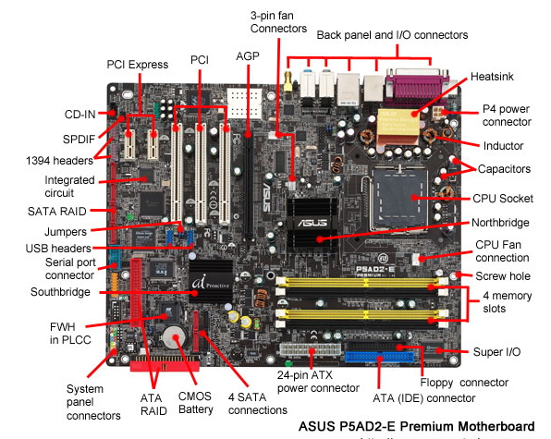

**Internal Structure of a Mother Board::**

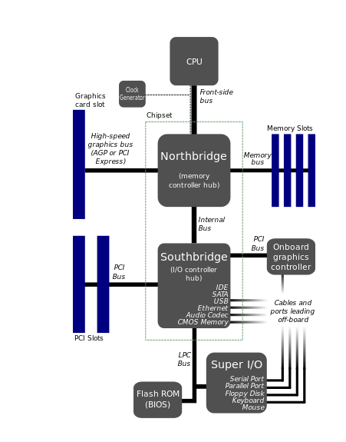

**Hard Disk Portioning and Formatting at the Time of Installation:**

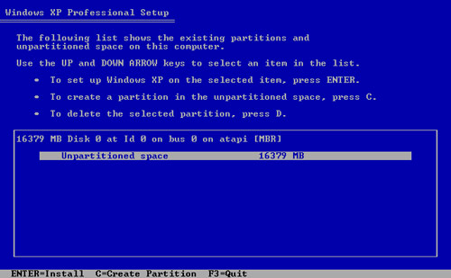 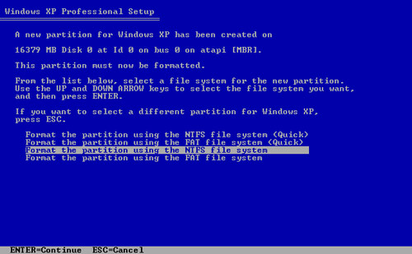

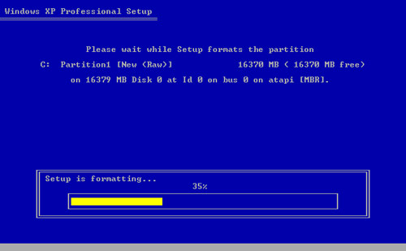

***BIOS Setup (CMOS)***

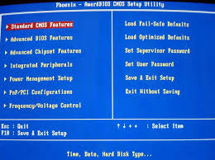 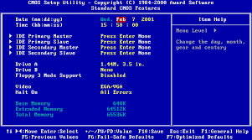

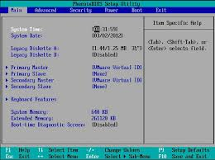 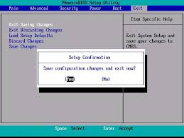

**Hard Disk Portioning and Formatting in windows:**

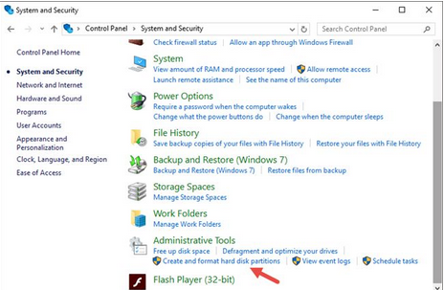

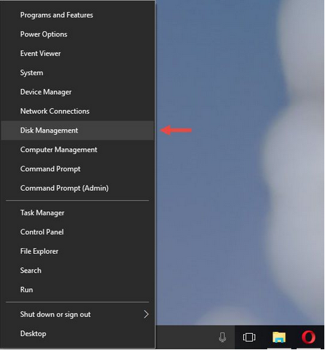

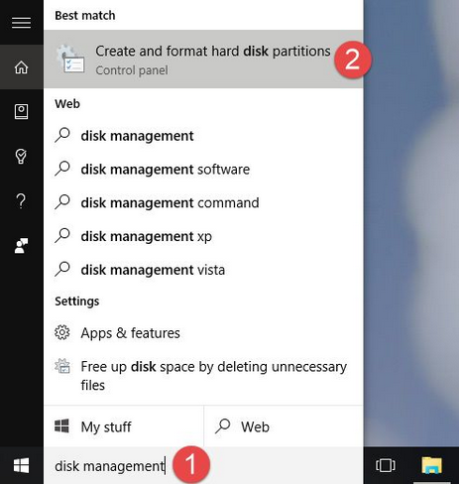

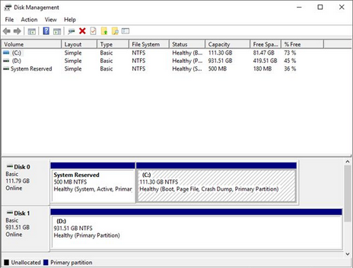

**Peripheral Components**

Keyboard, mouse, Printer, Scanner, Display, Speakers

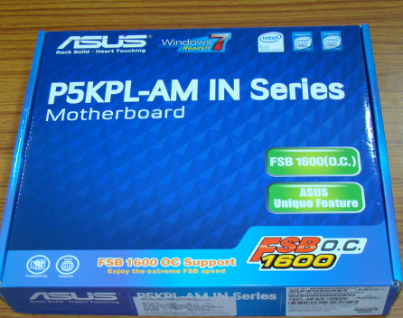 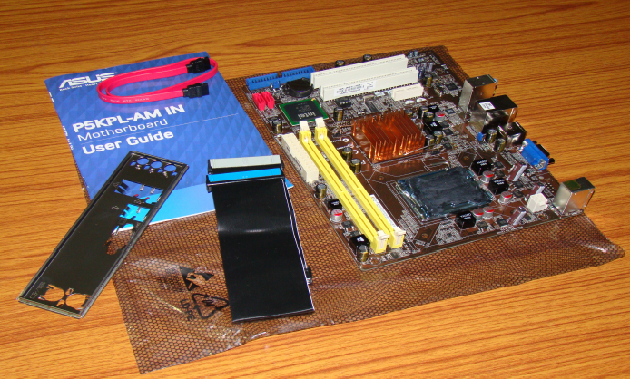

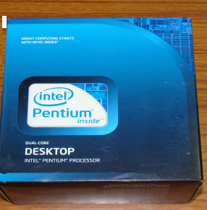 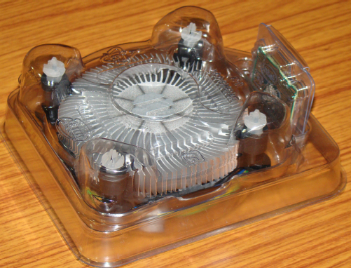

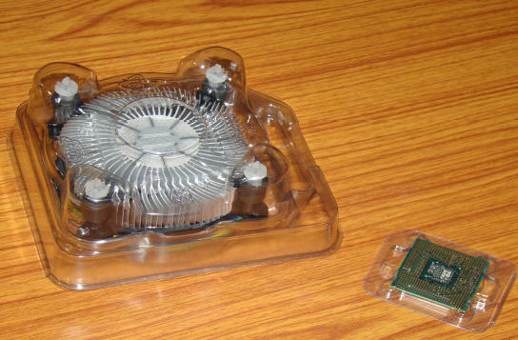 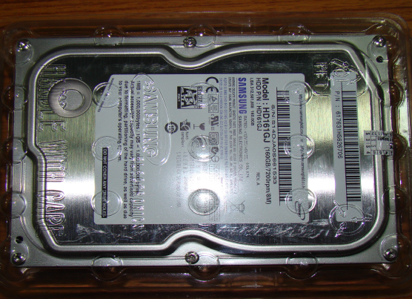

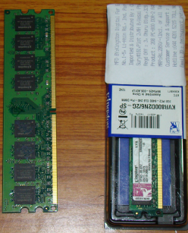 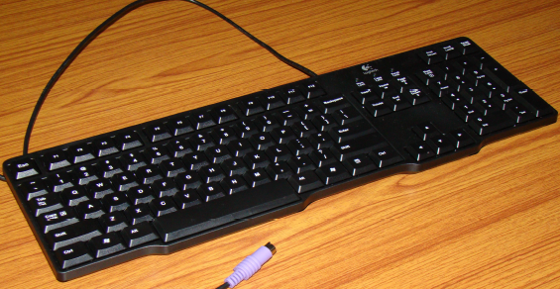

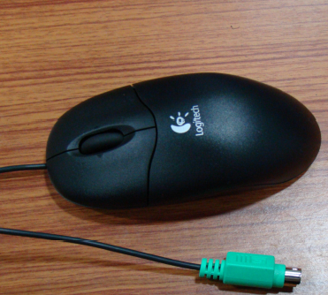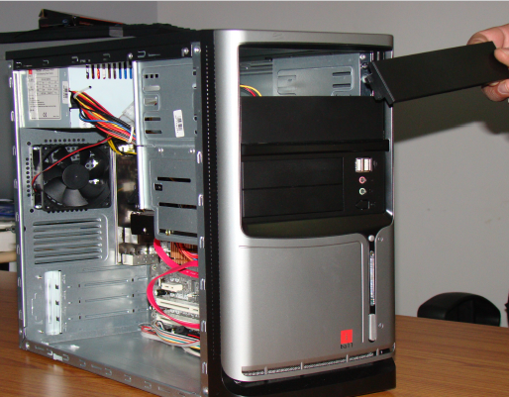

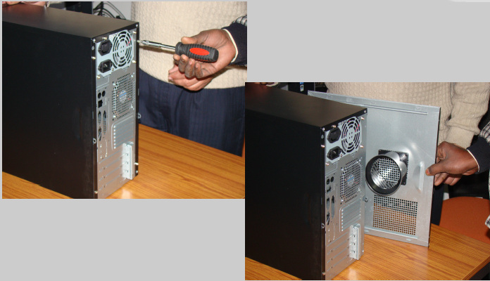

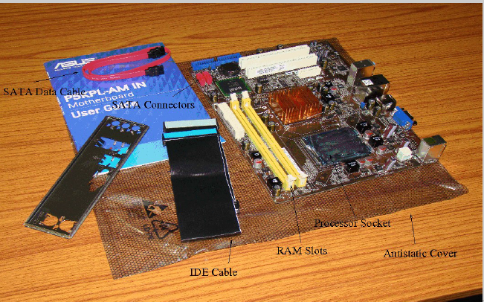 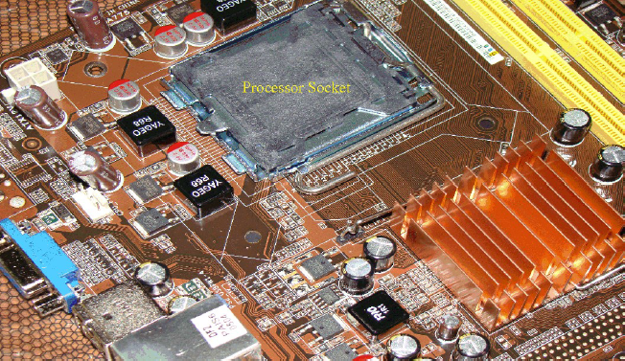

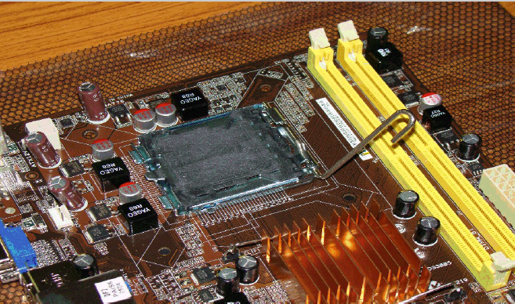 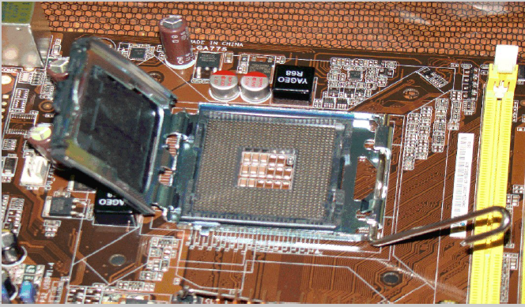

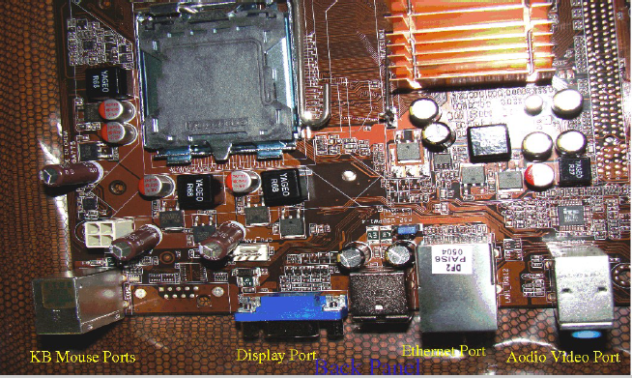 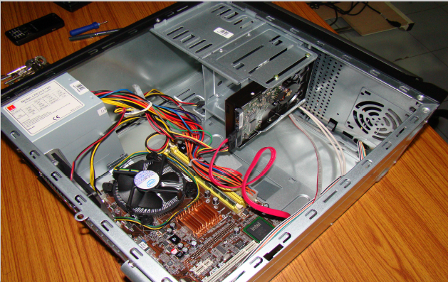

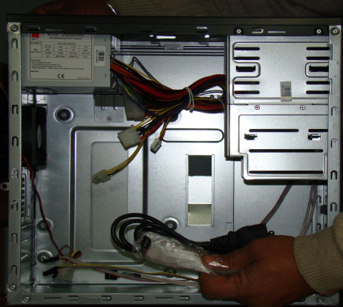 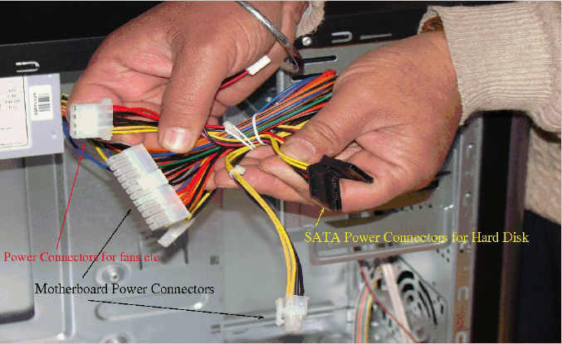

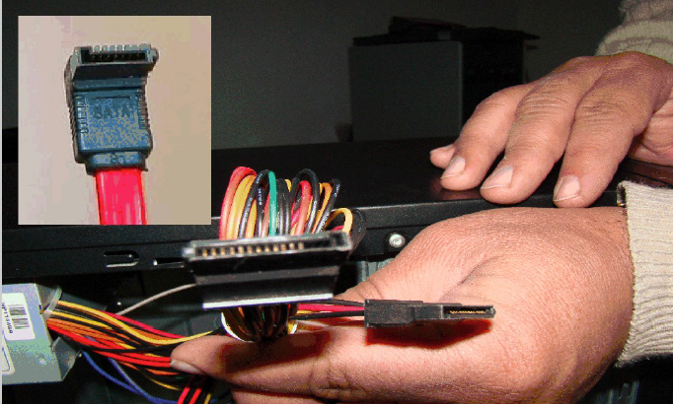 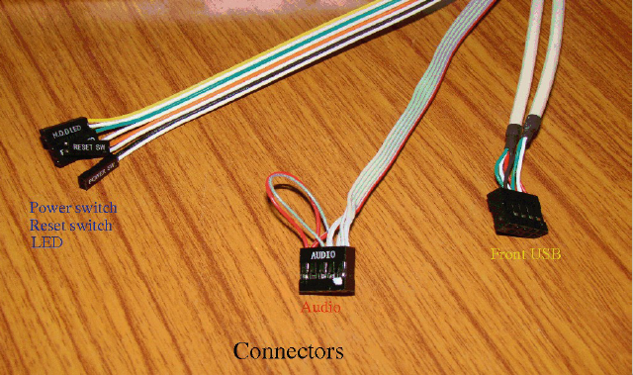

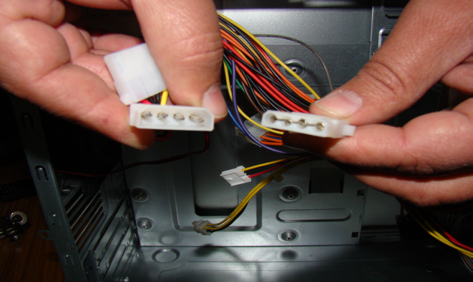 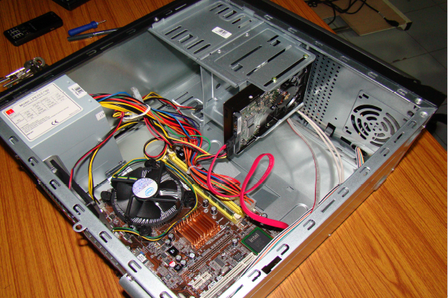

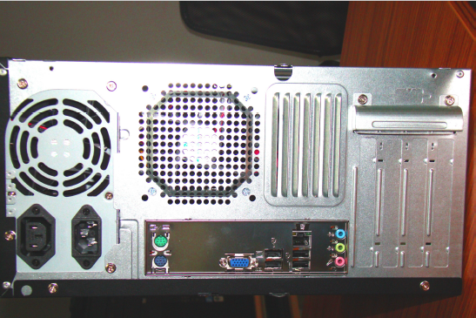 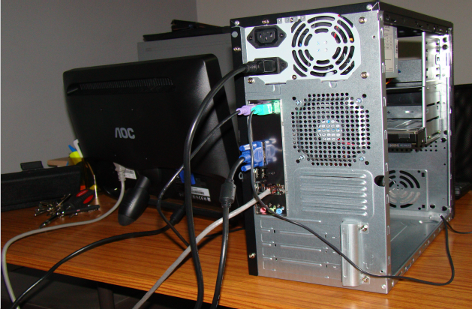

**OUTPUT:-**



|  |  |  |  |  |  |  |
| --- | --- | --- | --- | --- | --- | --- |
| HTNO | STUDENT NAME | DMS | JAVA | CO | OS | AFM |
| 2723114 | Venkatesh | 66 | 55 | 60 | 65 | 62 |
| 2723115 | Hrasha | 66 | 55 | 60 | 65 | 62 |
| 2723116 | Ramakrishna | 66 | 55 | 60 | 65 | 62 |
| 2723117 | Siva | 66 | 55 | 60 | 65 | 62 |
| 2723118 | rajashekhar | 66 | 55 | 60 | 65 | 62 |
| 2723119 | Ramu | 66 | 55 | 60 | 65 | 62 |
| 2723120 | Vishnu | 66 | 55 | 60 | 65 | 62 |
| STNO | STUDENT NAME | DMS | JAVA | CO | OS | AFM |
| 2723114 | Venkatesh | 66 | 55 | 60 | 65 | 62 |

|  |  |  |  |  |  |  |
| --- | --- | --- | --- | --- | --- | --- |
| STNO | STUDENT NAME | DMS | JAVA | CO | OS | AFM |
| 2723114 | Hrasha | 66 | 55 | 60 | 65 | 62 |

|  |  |  |  |  |  |  |
| --- | --- | --- | --- | --- | --- | --- |
| STNO | STUDENT NAME | DMS | JAVA | CO | OS | AFM |
| 2723115 | Ramakrishna | 66 | 55 | 60 | 65 | 62 |

|  |  |  |  |  |  |  |
| --- | --- | --- | --- | --- | --- | --- |
| STNO | STUDENT NAME | DMS | JAVA | CO | OS | AFM |
| 2723115 | Siva | 66 | 55 | 60 | 65 | 62 |

|  |  |  |  |  |  |  |
| --- | --- | --- | --- | --- | --- | --- |
| STNO | STUDENT NAME | DMS | JAVA | CO | OS | AFM |
| 2723115 | rajashekhar | 66 | 55 | 60 | 65 | 62 |

|  |  |  |  |  |  |  |
| --- | --- | --- | --- | --- | --- | --- |
| STNO | STUDENT NAME | DMS | JAVA | CO | OS | AFM |
| 2723115 | Ramu | 66 | 55 | 60 | 65 | 62 |

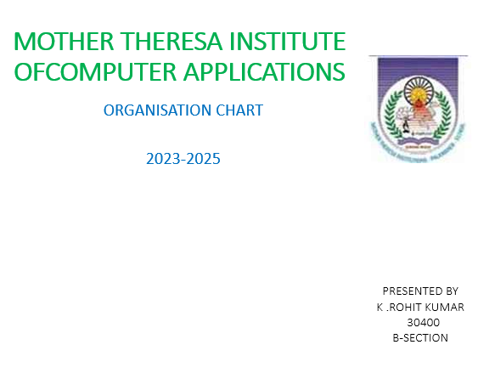****

PRESENTED BY

K .ROHIT KUMAR

30400

B-SECTION

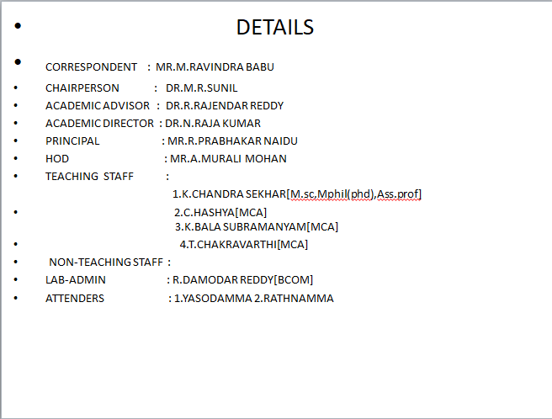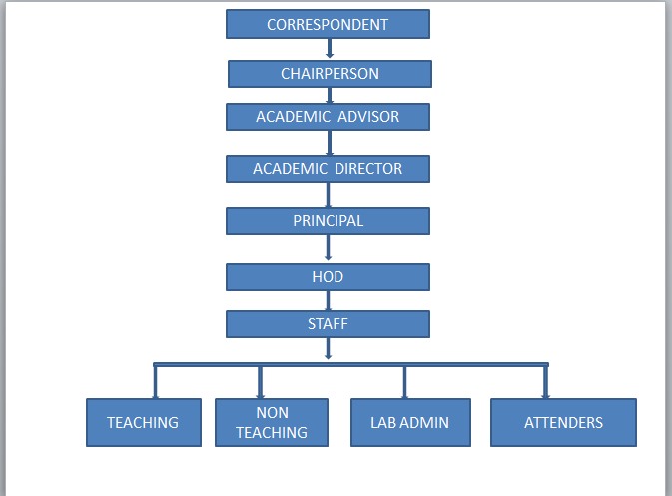

**CURRICULUM VITAE**

K.ROHIT KUMAR

Mobile:7670834556

Email:kudumurohithkumar@Gmail.Com

OBJECTIVE:

**To prove my self dedicated and energetic in a progressive organization that gives me scope to apply my knowledge and skills & be a member of a team that dynamically works to wards success & growth of the organization**

EDUCATION QUALIFICATIONS:s

|  |  |  |  |  |  |
| --- | --- | --- | --- | --- | --- |
| COURSE | UNIVERSITY | | YEAR OF PASSING | PERCENTAGE | |
| BSC[MPCS] | MOTHER THERESA DEGREE COLLEGE | 2023 | | | 85% |
| MPC | SAI SRI CHAITANYA JUNIOR COLLEGE | 2020 | | | 86% |
| SSC | Z.P.HIGH SCHOOL PONNAMAKULAPALLE | 2018 | | | 88% |
|  |  |  | | |  |

TECHNICAL SKILLS:

JAVA

PYTHON

MS WORD

PERSONAL SKILLS:

GOOD COMMUNICATION

HARD WORKING

PERSONAL DETAILS :

NAME : K.ROHIT KUMAR

MOBILE : 7670834556

DATE OF BIRTH :23-02-2003

HOBBIES : PLAYING CRICKET,LISTENING SONGS,MOVIES, FAREMING

LANAGUAGES KNOWN : TELUGU,ENGLISH

EMAIL : [kudumurohithkumar@gmail.com](mailto:kudumurohithkumar@gmail.com)

DECLARATION :

I here declared all the above information is true about my knowledge and believe

PLACE : THATHI REDDY PALLE

DATE : 16-02-2024 SIGNATURE

K.ROHIT KUMAR



***12 Heat Sink installation***

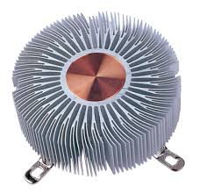 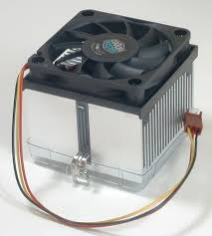 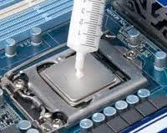

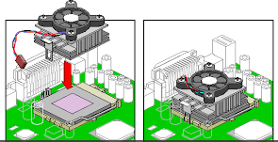 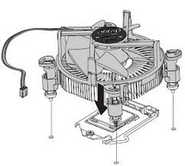

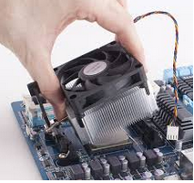 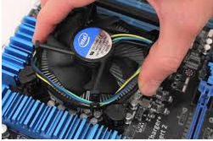 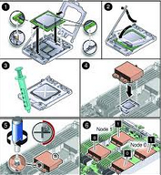

***12 Heat Sink installation***

  

** **

**  **